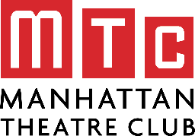

TheatreLink 2021

GROUP PROFILE
(For each group, complete all items that apply.)

Student Name(s):
Inward-Facing Items
(Activity: Clubs, Teams, Shops, and the Like)

Group Name:

Purpose or “Mission”:

Motto:

Rituals or Procedures:

History/Traditions:

Structure/Hierarchy:

Outward-Facing Items
(Activity: The Outside World)

Clients/Beneficiaries:

Allies:

Antagonists:

